WEEK 1 TASK REPORT
Exploratory Data Analysis and Insight Generation using Tableau
Dataset: Tableau Sample – Superstore

1. Introduction
This report presents an exploratory data analysis (EDA) of the Tableau Sample – Superstore dataset using Tableau Desktop. The objective of the analysis is to understand the structure of the sales data, identify important trends and variations, examine relationships between sales, profit and discount, and generate business-oriented insights through visualizations. Multiple worksheets were created so that each analytical question could be explored separately before combining the findings into a dashboard.

2. Objective
The main objective of this task is to perform an initial exploratory analysis and convert the observations into clear visual and narrative insights. The analysis focuses on sales performance over time, category-wise sales and profit, regional sales, sub-category performance, and the relationship between discount and profit.

3. Dataset Description
The analysis uses the Tableau Sample – Superstore dataset. It contains transactional information related to customer orders, products, locations, sales, profit, quantity, discount and dates. The dataset is suitable for EDA because it contains categorical, numerical, geographic and time-based variables.

4. Key Variables Used
Variable | Type | Purpose
Order Date | Date | Analyze sales trends over time
Sales | Numerical | Measure revenue/sales performance
Profit | Numerical | Evaluate profitability
Discount | Numerical | Study discount levels and their relationship with profit
Category | Categorical | Compare Furniture, Office Supplies and Technology
Sub-Category | Categorical | Identify detailed product-level sales patterns
Region | Categorical | Compare regional sales performance
Customer Name | Categorical | Understand customer-level dimensions
Quantity | Numerical | Examine order volume

5. Tools and Technologies
- Tableau Desktop – data exploration and visualization
- Tableau Sample – Superstore – dataset
- Tableau worksheets and dashboard – presentation of findings

6. EDA Methodology
The analysis was performed in stages. First, the dataset was connected to Tableau and the available fields were reviewed. Next, individual worksheets were created to answer specific questions. Bar charts were used for category, regional and sub-category comparisons; a line chart was used to study the sales trend over time; and a scatter plot was used to explore the relationship between discount and profit. Finally, the worksheets were combined into a single exploratory dashboard.

7. Visualizations Created

7.1 Sales Trend Over Time
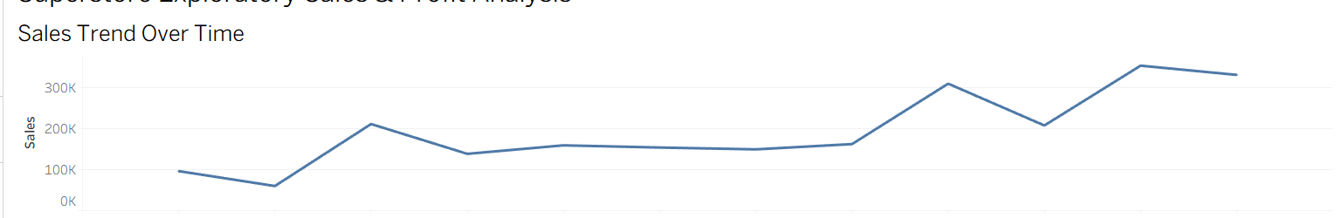
Figure 1: Sales Trend Over Time
A line chart was created using Order Date and Sales. The visualization shows that sales vary across months rather than remaining constant. There are noticeable increases during some later months, with the highest visible sales occurring around month 11, followed by a slight decrease in month 12. The trend suggests that time-based demand patterns may be important for planning inventory and sales activities.

7.2 Sales by Category
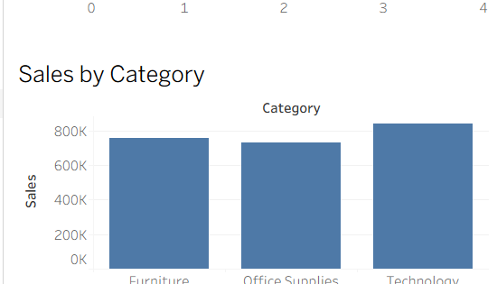
Figure 2: Sales by Category
A bar chart compares sales across Furniture, Office Supplies and Technology. Technology has the highest sales among the three categories in the dashboard, while Office Supplies has the lowest. Furniture remains between the other two categories. This comparison helps identify which broad product category contributes more strongly to overall sales.

7.3 Profit by Category
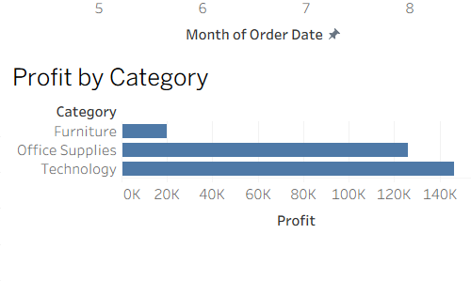
Figure 3: Profit by Category
Profit was compared across the same three categories. Technology shows the highest profit, followed by Office Supplies, while Furniture records the lowest profit among the three categories. The result indicates that sales volume and profitability should be examined together rather than using sales alone as the measure of performance.

7.4 Sales by Region
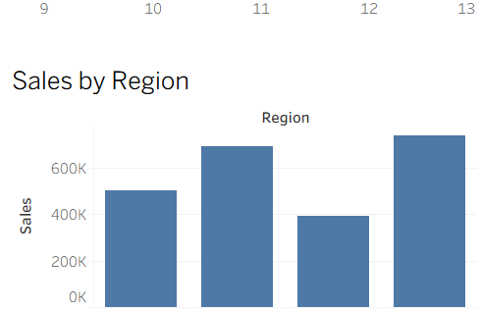
Figure 4: Sales by Region
Regional sales were visualized for Central, East, South and West. The West region has the highest sales in the dashboard, followed by East. Central is lower than these two regions, while South has the lowest sales. This regional variation can be useful for identifying areas that may require deeper customer, product or marketing analysis.

7.5 Sales by Sub-Category
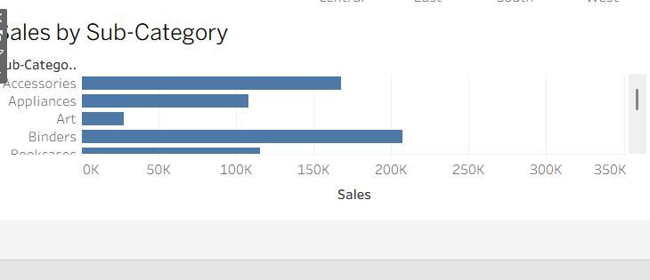
Figure 5: Sales by Sub-Category
The sub-category bar chart provides a more detailed view than the category chart. The visualization shows substantial differences in sales among individual sub-categories. Chairs and Binders are among the larger sales contributors in the displayed analysis, while smaller sub-categories such as Fasteners and Envelopes have comparatively lower sales. This demonstrates why sub-category analysis is useful for detailed product planning.

7.6 Discount vs Profit
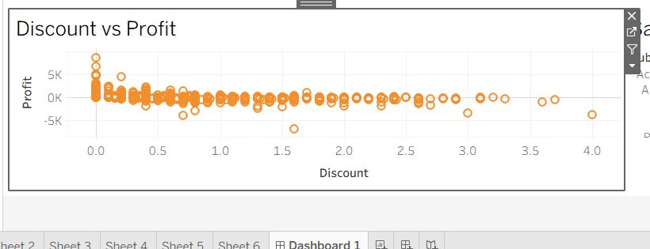
Figure 6: Discount vs Profit
A scatter plot was created with average discount on the horizontal axis and profit on the vertical axis. The points show a wide distribution of profit values, including both positive and negative profit observations. Several observations with higher discount levels are associated with low or negative profit, although the chart alone does not establish a causal relationship. This area requires further analysis by category, sub-category, region and product.

8. Key Insights
- Sales change over time, with stronger sales visible during some later months.
- Technology is the highest-sales category in the current dashboard.
- Technology also records the highest category-level profit in the current analysis.
- West has the highest regional sales, while South has the lowest among the four displayed regions.
- Sub-category performance varies considerably, indicating that category-level analysis can hide important details.
- The discount-profit scatter plot contains both positive and negative profit observations, indicating that discounting should be examined carefully.

9. Potential Business Questions for Further Investigation
- Which products or sub-categories generate high sales but relatively low profit?
- At what discount levels do negative-profit transactions become more frequent?
- Why does the South region have lower sales than the other regions?
- Which months consistently show stronger sales, and can seasonality be identified?
- How do sales and profit vary by customer segment?
- Are there specific products or regions where discounts are particularly high?

10. Limitations
This is an initial exploratory analysis and does not attempt to establish causal relationships. The visualizations identify patterns that should be investigated further. In particular, the relationship between discount and profit may be affected by product type, order size, region and other variables. Additional statistical analysis and more detailed filtering would be required before using these observations for operational decisions.

11. Conclusion
The Tableau EDA demonstrates how transactional sales data can be transformed into useful visual insights. The dashboard brings together time trends, category comparisons, regional performance, sub-category analysis and discount-profit relationships in one view. The analysis indicates clear differences across categories, regions and time periods and highlights discount-profit behavior as an area requiring deeper investigation. Overall, the exercise demonstrates the usefulness of Tableau for exploratory analysis, pattern discovery and communicating business-oriented findings.

12. Dashboard Overview
The final dashboard, titled “Superstore Exploratory Sales & Profit Analysis,” combines the six major views created during the EDA: Sales Trend Over Time, Sales by Category, Profit by Category, Sales by Region, Discount vs Profit and Sales by Sub-Category. The dashboard is designed to allow a reader to understand overall performance first and then explore specific dimensions.
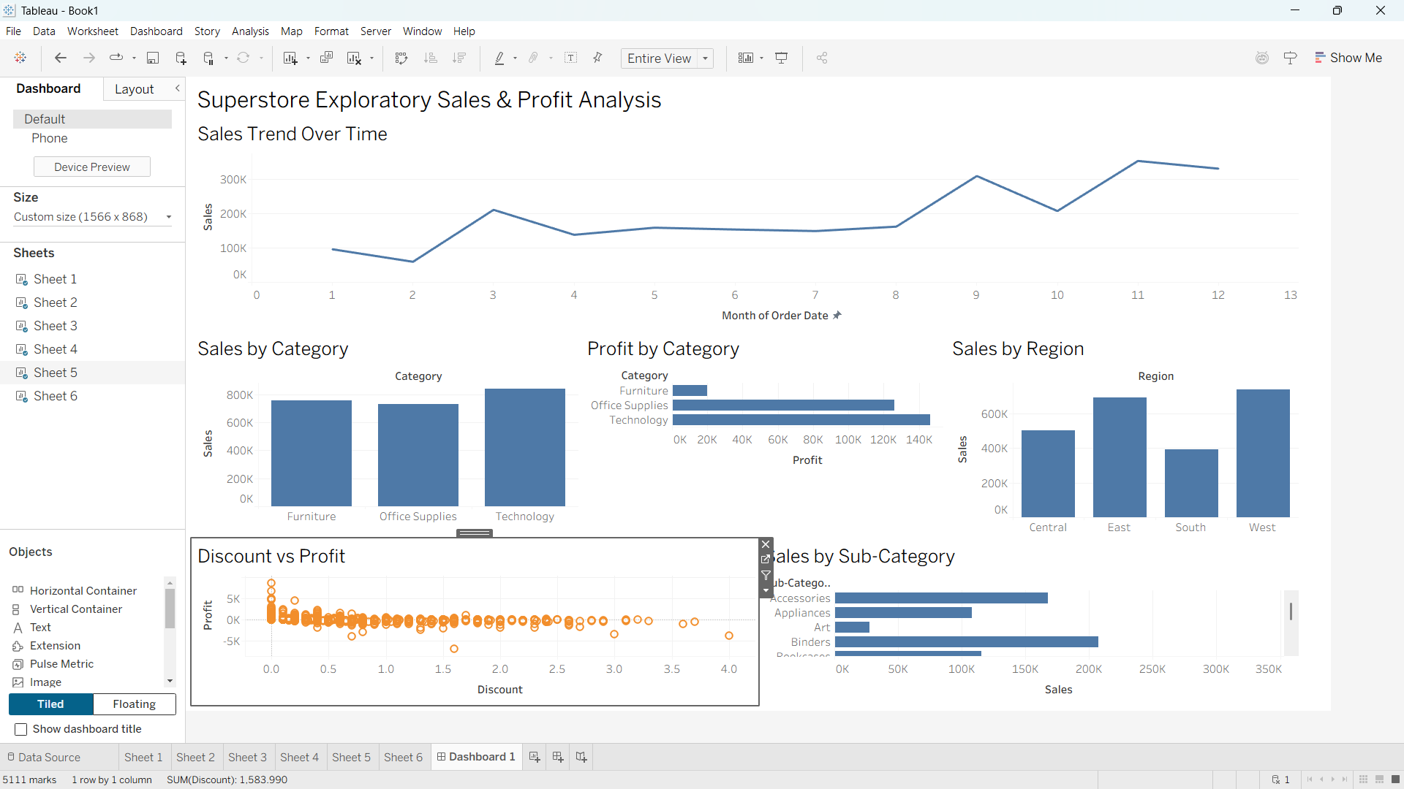
Figure 7: Final Tableau Exploratory Sales & Profit Analysis Dashboard

13. Submission Note
Screenshots of the individual Tableau worksheets and the final dashboard can be inserted into this document under the corresponding sections to provide visual evidence of the analysis process.

